…………that is until you have a plan for your continued education! Let’s face it, attending college (or other post high school training) is the largest investment decision of your life so far - whether using your money (via loans) or your parents! Studies⁽¹⁾ show that only 40% of college students graduate within 4 years, and the graduation rate after 6 years is only 60% - not very promising based upon the investment at stake! Take the time now to make your investment count!
Typically, high school students choose a college/career this way:

When you could make your decision this way and help ensure your success:

Before making such a large investment of time and money, why not do some important planning to help you:
- Choose a career field that best fits your natural abilities and has a positive, long-term economic opportunity
- Target a college program or advanced training that leads to graduation in less time – saving you money
- Improve your chances of securing a promising, satisfying career upon graduation
- Develop skills you can rely on to successfully navigate the inevitable ebbs and flows of your career and life.

The “Don’t Send Your Student to College….” Career Coaching Program will help you align your purpose, your passions, and your future paycheck to attain greater professional and personal satisfaction from your career – and establish a firm foundation for achieving financial freedom in the process! Upon completion, you will be equipped to turn your “human capital” (aka your collective education and experience) into “financial capital” (aka long-term savings and investments).
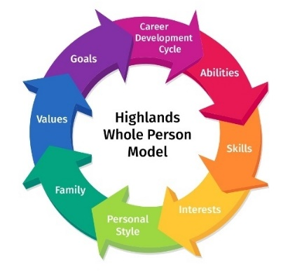
The Program, utilizing the Highlands Ability Battery and The Whole Person Model (www.highlandsco.com), will help you discover what you do best – naturally – and guide you to a promising, satisfying career through the development of a Personal Career Vision Statement and “Lens” – a way of determining your ideal career opportunity and their path to finding it.

Program Overview

Phase 1
Professional assessment of your natural abilities using the Highlands Ability Battery (www.highlandsco.com) with detailed reports that outline:
- How you best learn
- How you best communicate
- How you best solve problems & approach opportunities
- Your preferred work environment
- The work types (functions/responsibilities) that best fit your natural abilities
- Career fields that match your profile and may present unique opportunities for you to succeed
Phase 1 includes a 2-hour one on one session with Ray Giese, CFP®, MS to help you better understand your results. This insight leads you to your most ideal career fields for consideration – before you devote time and money pursuing it.

Phase 2
- 10 coaching sessions leading to the creation of your personal career vision and “lens” to help you determine the “best fit” career for you. It will equip you to best articulate what you want – putting others in position to better understand your goals and help you get there;
- Professional guidance from Ray Giese, CFP®, MS and a Highlands Certified Consultant;
- All resources for the coaching sessions, including the Career Development Workbook, Don’t Waste Your Talent text, and additional online tools to help you assess career options;

Session 1 | Introduction to The Whole Person Model | Session 6 | Surveying for Validation
Session 2 | Understanding Your Natural Abilities &  Work Types | Session 7 | Creative Integration – Your Personal Career Vision
Session 3 | Your Skills, Interests, & Work Personality | Session 8 | Putting it All Together
Session 4 | Your Personal Values, Goals, and Family Background | Session 9 | Presentations & Feedback
Session 5 | Identifying & Evaluating Career Fields That Match You | Session 10 | Making It Happen – Next Steps
- National Center for Education Statistics - https://nces.ed.gov

Pricing (reflects individual pricing – custom pricing for groups greater than 5)
___1. Phase 1 Only - Highlands Ability Battery, custom reports, and 2-hour debrief (HAB Process) – one-time payment $ 395.00

___2. Combined HAB Process + 10 Self Discovery Sessions (10 hours) + materials:
___Combined program - one-time payment prior to start of process $1645.00

___Combined program - Six monthly payments ($285 x 6) $1710.00

Note: there is a 10% discount on pricing for 2-5 Clients that register at the same time

Contact Ray Giese, CFP®, MS to register or if you have further questions – contact information below:

